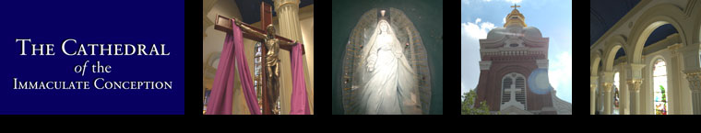

Bequest Form/Codicil

I give, devise and bequeath to the Cathedral of the Immaculate Conception, 416 W. 12th Street, Kansas City, Missouri, 64105 $____________________ for the specific purposes (if any) of said Church or Ministry, to be determined by its governing authority.

__________________________________ __________________________________
Full Name Spouse’s Full Name (If Applicable)

__________________________________ _________________________________
Address City, State, Zip Code

__________________________________ ___________________________________
Signature Spouse’s Signature (If Applicable)

__________________________________
Date

You should execute the Bequest Form/Codicil in the same manner as the will. Sign your will in the presence of two witnesses.
Store your Bequest Form/Codicil with your last will and testament.

